How to import an existing Keil 4.x project into CCS6.1

1) Download and unzip the **ValvanoWaveTM4C123** set of starter projects. Each folder has a CCS6.1 and Keil 4.x project. http://users.ece.utexas.edu/~valvano/arm/ValvanoWaveTM4C123.zip

2) Create a new CCS6.1 project and select the TM4C123GH6PM processor and Stellaris ICDI debugger. I select the Empty Project (with main.c). I select the project name to match the folder name of the original Keil project. Click finish.

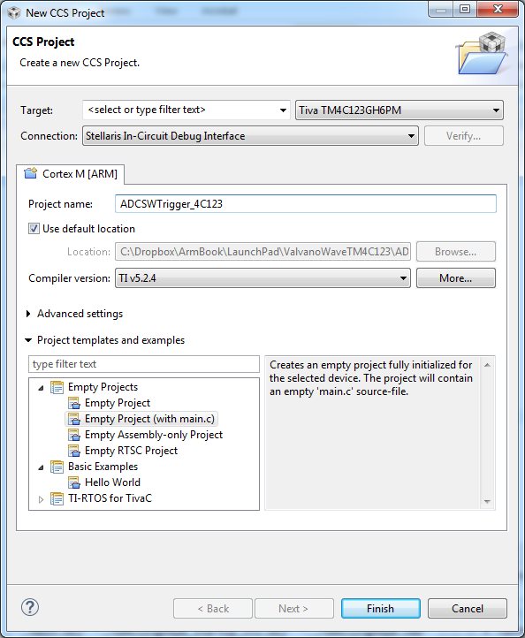

When creating assembly projects, make sure the Properties -> Linker -> Basic Options -> Set System C stack size is set to something reasonable like 512 bytes.

3) In Project->Properties. Under Build -> ARM Compiler -> Advanced Options- > Language Options, I select C99

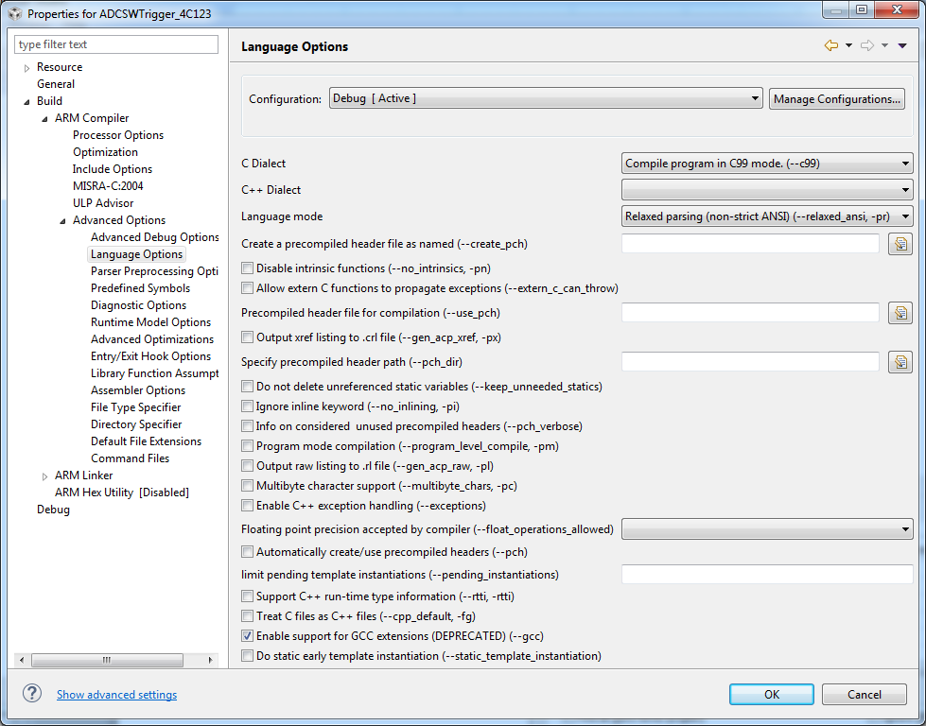

4) In Project->Properties. Under Build -> ARM Compiler -> Advanced Options- > Assembler Options, I like C interlisted assembly files

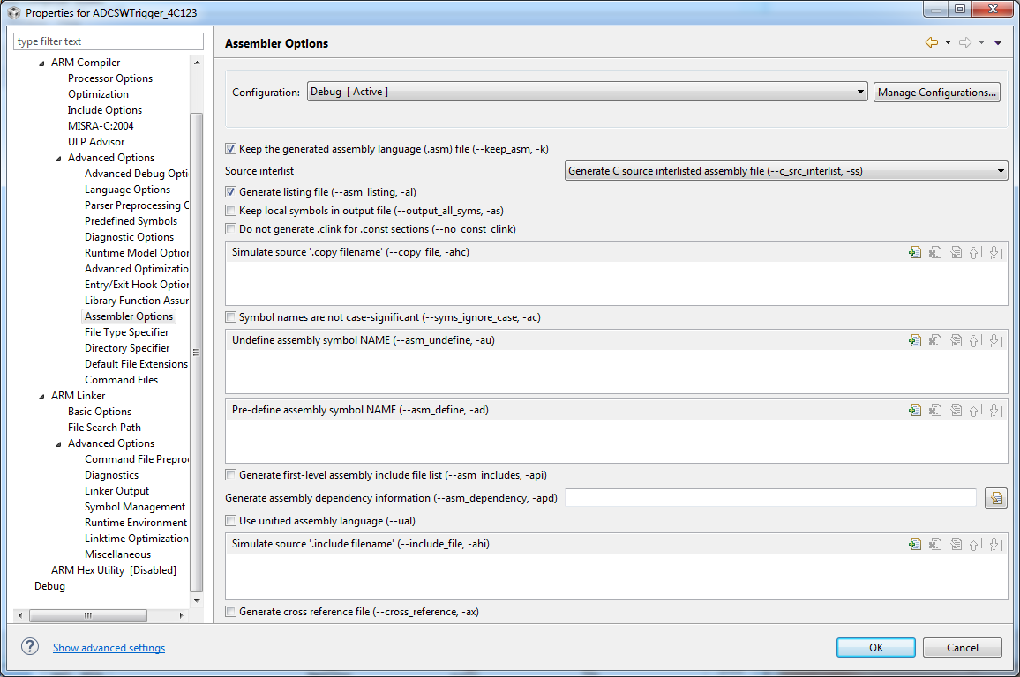

5) In Project->Properties. Under Debug -> Flash settings, select 16 MHz crystal 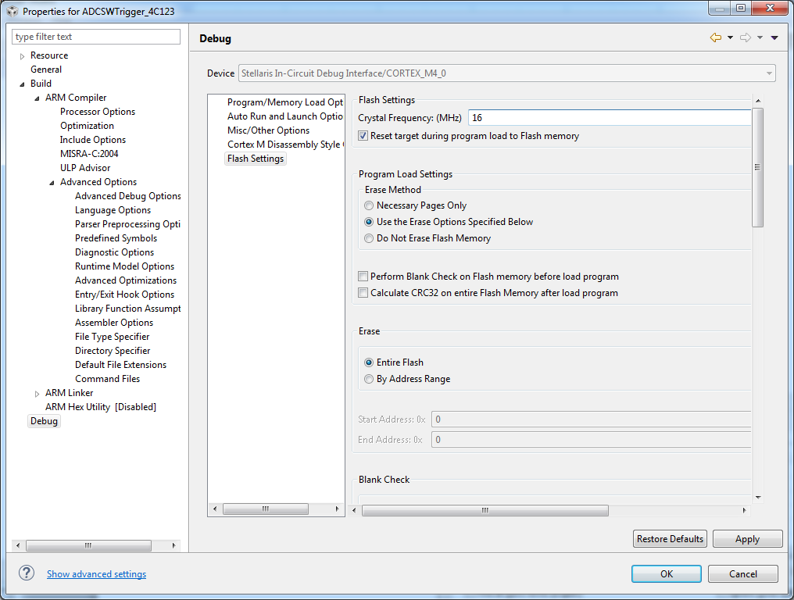

6) At this point the project should build and debug (no need to run because it doesn’t do anything).

7) Quit CCS. Copy all files from the Keil project into the CCS folder created in step 2). If the Keil had a **main.c**, then overwrite the CCS **main.c** file. If the Keil did not have a **main.c**, then delete the CCS **main.c** file.

Copy the file **tm4c123gh6pm_startup_ccs.c** from one of the existing projects in **ValvanoWaveTM4C123** replacing the one created in step 2.

8) Open CCS back up and select the new project. Exclude any Keil-specific files like **startup.s**

